**PIZZA SALES SQL QUERIES**

**A. KPI’s**

**1. Total Revenue:**

**Select Sum(total_price) as Total_Revenue From pizza_sales;**

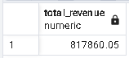

**2. Average Order Value**

**Select Sum(total_price) / count(distinct(order_id)) as order_vlaue From pizza_sales;**

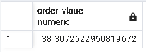

**3. Total Pizzas Sold**

**Select Sum(quantity) as Total_pizza_sold from pizza_sales;**

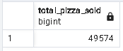

**4. Total Orders**

**Select count(distinct(order_id)) as "Total_Order" From pizza_sales;**

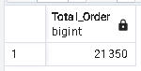

**5. Average Pizzas Per Order**

**Select Sum(quantity) / Count (Distinct(order_id)) as "Total Order" From pizza_sales**

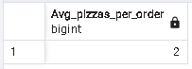

**B. Daily Trend for Total Orders**

**Select To_char(order_date,'Day') as "Order_Day", count(distinct(order_id)) as "Total_orders"**

**From pizza_sales**

**group by 1;**

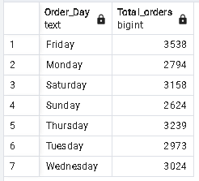

**C. Monthly Trend for Orders**

**Select To_char(order_date,'Month') as "Order_Month", count(distinct(order_id)) as "Total_orders"**

**From pizza_sales**

**group by 1;**

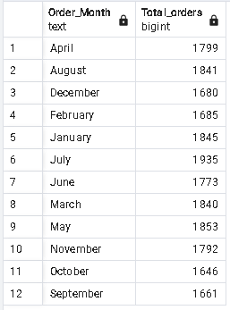

**D. % of Sales by Pizza Category**

**Select pizza_category,**

**Sum(total_price) as "Sales",**

**round((Sum(total_price)) * 100 / (select Sum (Total_price) From pizza_sales),2) as "percentage"**

**From pizza_sales**

**group by 1;**

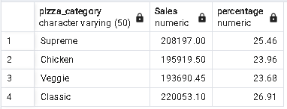

**E. % of Sales by Pizza Size**

**select * From pizza_sales;**

**Select pizza_size,**

**Sum(total_price) as "Sales",**

**round(Sum(total_price) * 100 /(Select Sum(total_price) as "Percentage" From pizza_sales),2)**

**From pizza_sales**

**group by 1;**

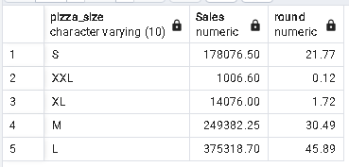

**F. Total Pizzas Sold by Pizza Category**

**Select pizza_category,Sum(quantity) as "Total_pizzas_Sold"**

**From pizza_sales**

**group by 1**

**order by Sum(quantity) desc;**

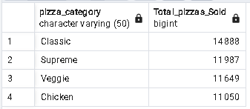

**G. Top 5 Pizzas by Revenue**

**Select pizza_name,Sum(total_price) as "Revenue"**

**From pizza_sales**

**group by 1**

**Order by Sum(total_price) desc**

**limit 5 ;**

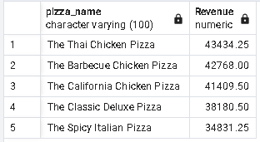

**H. Bottom 5 Pizzas by Revenue**

**Select pizza_name,Sum(total_price) as "Revenue"**

**From pizza_sales**

**group by 1**

**order by Sum(total_price) asc**

**limit 5;**

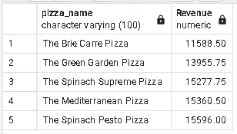

**I. Top 5 Pizzas by Quantity**

**Select pizza_name,Sum(quantity) as "Quantity"**

**From pizza_sales**

**Group by 1**

**Order by Sum(quantity) desc**

**limit 5 ;**

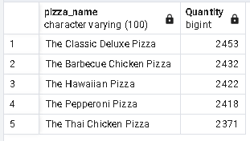

**J. Bottom 5 Pizzas by Quantity**

**Select pizza_name,Sum(quantity) as "Quantity"**

**From pizza_sales**

**group by 1**

**order by Sum(total_price) asc**

**limit 5;**

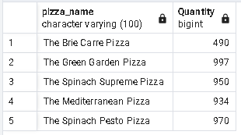

**K. Top 5 Pizzas by Total Orders**

**Select pizza_name,count(distinct(order_id)) as "Total_Orders"**

**From pizza_sales**

**group by 1**

**Order by count(distinct(order_id)) desc**

**limit 5;**

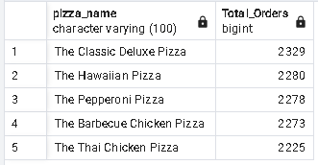

**L. Bottom 5 Pizzas by Total Orders**

**Select pizza_name,count(distinct(order_id)) as "Total_Orders"**

**From pizza_sales**

**group by 1**

**Order by count(distinct(order_id)) asc**

**limit 5;**

